Reverb Pedal based on BTDR-2 reverb chip
23/06/2025
Nick Schneider
This pedal build will be based on the schematic for a mono reverb pedal shown in the BTDR-2 datasheet. This pedal is designed to be more pedal-board friendly and space saving than a spring reverb. The price of the BTDR-2 being the main down-side, sitting at around $40 on PPA. The Primary design goals are:
- Recreate a working schematic from the one found on the BTDR-2 datasheet.
  - https://pedalpartsandkits.com/content/btdr2.pdf
- Include simulated input and output of the pedal on LTspice
- Fit all components into a 112mmL x 60mmW x 31mmH chassis
- Design and produce a PCB board on KiCad
Things to consider:

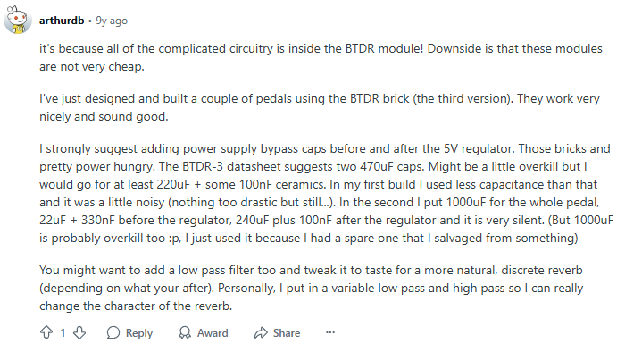

Bill of Materials
Item Name |  |  | Value | Model | Price (inc) | Total (inc) | Provider
1 x | BTDR-2H REVERB MODULE - LONG |  | BTDR-2H | ICSN0045 | $40.00 | $40.00 | PPA
3 x | METAL FILM RESISTOR - 10k |  | 10k | RESN0058 | $0.10 | $0.30 | PPA
2 x | METAL FILM RESISTOR - 39k |  | 39k | RESN0068 | $0.10 | $0.20 | PPA
1 x | MULTILAYER CERAMIC CAPACITOR - 22nf |  | 22n | CAPN0171 | $0.10 | $0.10 | PPA
1 x | 9mm POT PCB - 50K LINEAR |  | 50k Lin | PT090003 | $2.70 | $2.70 | PPA
1 x | METAL FILM RESISTOR - 22k |  | 22k | RESN0063 | $0.10 | $0.10 | PPA
1 x | 78L05 VOLTAGE REGULATOR |  | 78L05 | ICSN0011 | $0.70 | $0.70 | PPA
1 x | 7805 VOLTAGE REGULATOR* |  | 7805 | ICSN0028 | $0.70 | $0.70 | PPA
1 x | TL072 DUAL OPAMP |  | TL072 | ICSN0026 | $1.50 | $1.50 | PPA
1 x | IC SOCKET - DIL 8 WAY |  |  | CNPC0001 | $0.40 | $0.40 | PPA
4 x | METAL FILM RESISTOR - 1k |  | 1k | RESN0040 | $0.10 | $0.40 | PPA
1 x | NEVE STYLE KNOB - DARK BLUE |  |  | KNNV0005 | $4.50 | $4.50 | PPA
1 x | 3mm RECESSED METAL LED HOLDER |  |  | LDBZ0004 | $0.40 | $0.40 | PPA
1 x | 5mm LED WATERCLEAR - GREEN |  |  | LD5M0002 | $0.20 | $0.20 | PPA
1 x | 3PDT FOOTSWITCH |  | 3PDT | SWFS0001 | $4.70 | $4.70 | PPA
2 x | EST MONO COMPACT SOCKET |  |  | CNPH0021 | $4.00 | $8.00 | PPA
2 x | COMPACT 2.1mm DC PANEL MOUNT SOCKET |  |  | CNDC0012 | $1.00 | $2.00 | PPA
1 x | 1590B STYLE ALUMINIUM DIE CAST ENCLOSURE - WHITE |  | 1590B | ENAL0013 | $12.80 | $12.80 | PPA
Sub-Total: |  | $79.70
Australia Post (Standard Parcel to AU): |  | $5.00
Total: |  | $84.70

*PPA provider is online at www.pedalpartsaustralia.com
*second voltage regulator was purchased for testing

